**OUTPUT**:-

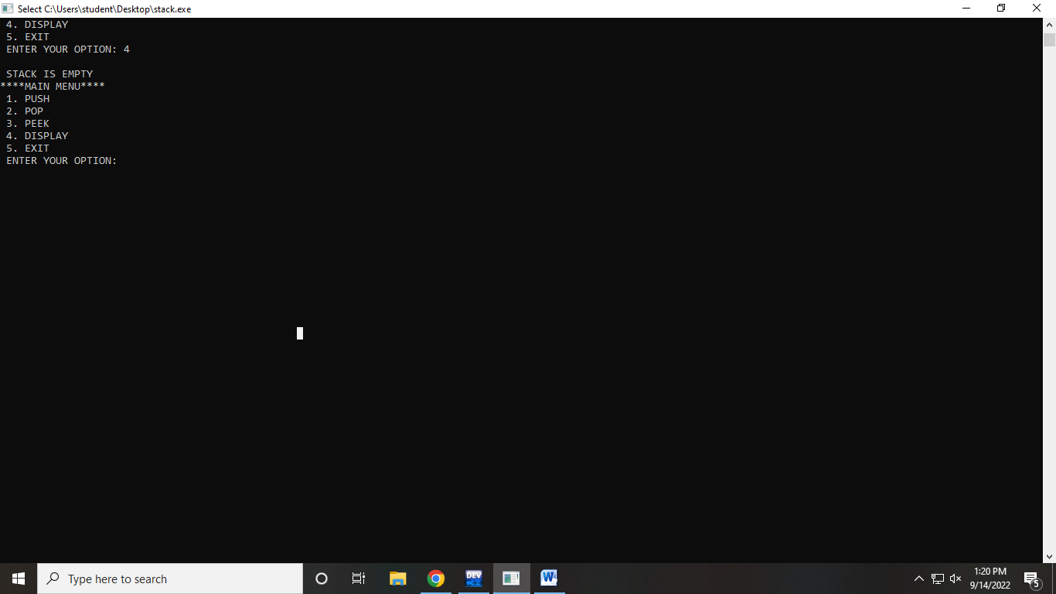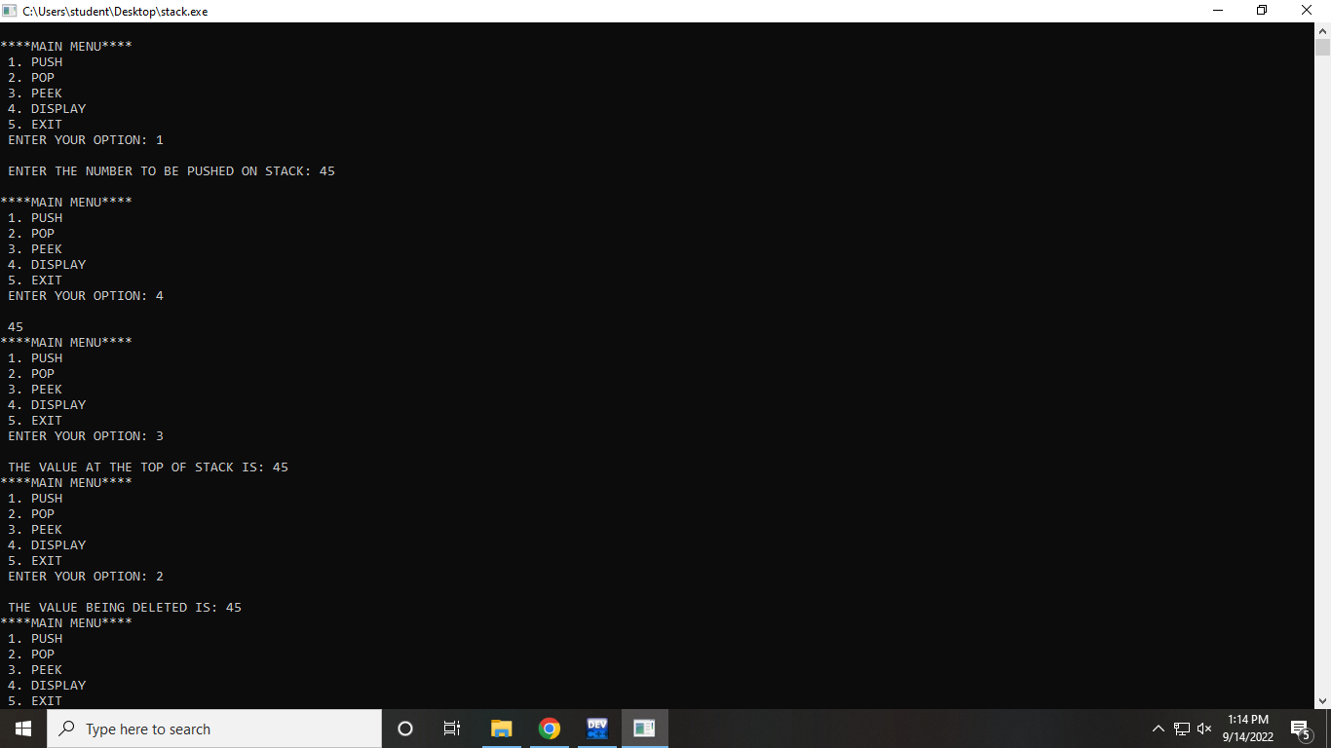

**PROGRAM CODE:**

#include<stdio.h>

#include<stdlib.h>

#include<malloc.h>

struct stack

{

int data;

struct stack*next;

};

struct stack*top =NULL;

struct stack*push(struct stack *,int);

struct stack*display(struct stack *);

struct stack*pop(struct stack *);

int peek(struct stack*);

int main(int argc,char*arv[]){

int val,option;

do

{

printf("\n****MAIN MENU****");

printf("\n 1. PUSH");

printf("\n 2. POP");

printf("\n 3. PEEK");

printf("\n 4. DISPLAY");

printf("\n 5. EXIT");

printf("\n ENTER YOUR OPTION: ");

scanf("%d",&option);

switch(option)

{

case 1:

printf("\n ENTER THE NUMBER TO BE PUSHED ON STACK: ");

scanf("%d",&val);

top=push(top, val);

break;

case 2:

top=pop(top);

break;

case 3:

val= peek(top);

if(val !=-1)

printf("\n THE VALUE AT THE TOP OF STACK IS: %d",val);

else

printf("\n STACK IS EMPTY");

break;

case 4:

top=display(top);

break;

}

}while(option!=5);

return 0;

}

struct stack*push(struct stack*top,int val)

{

struct stack*ptr;

ptr=(struct stack*)malloc(sizeof(struct stack));

ptr ->data=val;

if(top==NULL)

{

ptr ->next =NULL;

top = ptr;

}

else

{

ptr ->next =top;

top= ptr;

}

return top;

}

struct stack *display(struct stack*top)

{

struct stack*ptr;

ptr=top;

if(top==NULL)

printf("\n STACK IS EMPTY");

else

{

while(ptr!=NULL)

{

printf("\n %d",ptr->data);

ptr = ptr -> next;

}

}

return top;

}

struct stack*pop(struct stack*top)

{

struct stack*ptr;

ptr= top;

if(top==NULL)

printf("\n STACK UNDERFLOW");

else

{

top=top-> next;

printf("\n THE VALUE BEING DELETED IS: %d",ptr->data);

free(ptr);

}

return top;

}

int peek(struct stack*top)

{

if(top==NULL)

return -1;

else

return top ->data;

}